Task 23 – MySql and JDBC Connectivity

Question 1 : MySql Operations

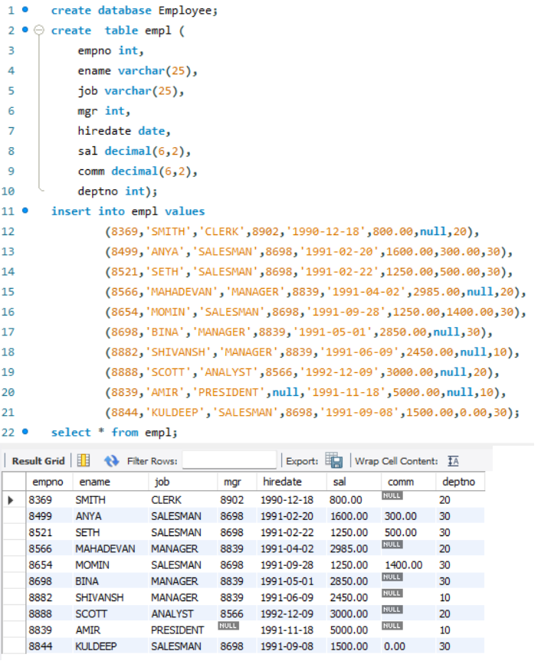

Screenshot of creation of database, table and adding data to the table

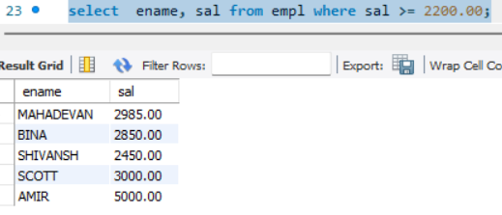

Q1.A: Query to display employee name and salary of employees whose salary is greater than or equal to 2200

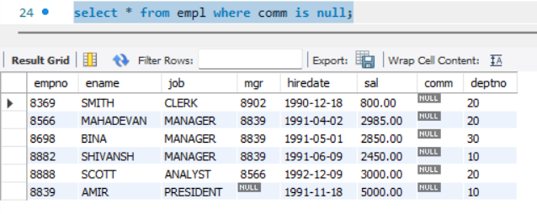

Q1.B: Details of employees who doesn’t get any commission

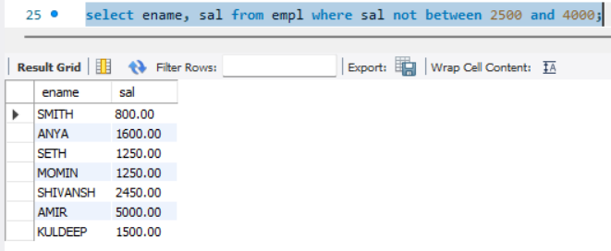

Q1.C: Name and Salary of employees who don’t have their salary in the range of 2500 to 4000

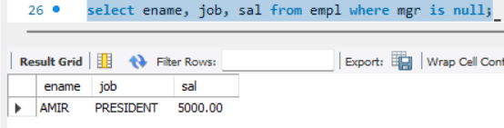

Q1.D: Name, Job title and salary of employee who don’t have a manager

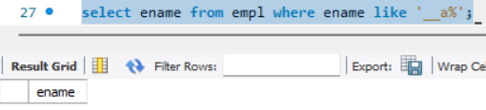

Q1.E: Name of employees whose name has alphabet ‘a’ as third name. No employee name in the table matches this condition, so it returns no result

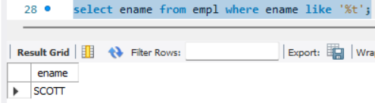

Q1.F: Name of employee whose name has ‘t’ as the last alphabet

Question 2: JDBC Connectivity

